Explicit Waits

What it is:
- Waits for a specific condition on a specific element
- More precise than implicit waits
- Only applies where you use it, not global

How it works:
- Waits for a condition to be true (not just element presence) within given time
- Polls DOM until condition met or timeout

Syntax:
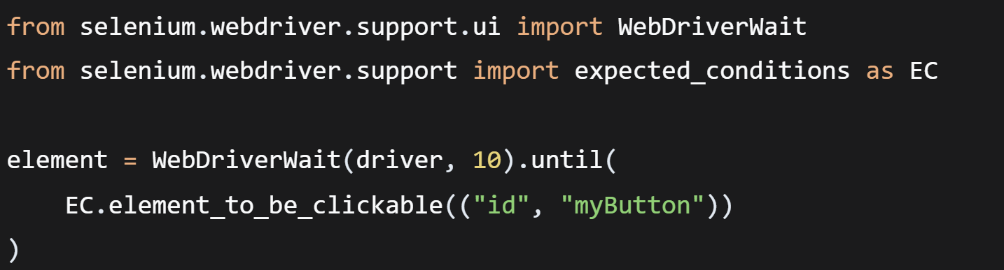

When to use:
- When you need element in specific state (clickable, visible)
- For dynamic content that loads at different times
- When different elements need different wait times

Important:
- More control than implicit waits
- Can wait for custom conditions
- Use when implicit wait isn't enough

Common Explicit Wait Conditions:
- element_to_be_clickable - exists + visible + enabled
- presence_of_element_located - exists in HTML (like implicit)
- visibility_of_element_located - exists + visible on page
- text_to_be_present_in_element - contains specific text
- title_contains - page title has text
- alert_is_present - alert popup exists
- invisibility_of_element - element hidden/removed
- staleness_of - element no longer attached to DOM

Fluent Waits
- Fluent wait is for when elements behave unpredictably.
- Advance version of explicit waits
- Example: A loading spinner that appears/disappears randomly.
- With normal explicit wait, if the element disappears during checking, it fails.
- With fluent wait, you can say: "Ignore when the element vanishes temporarily, just keep checking for 10 seconds."
- It handles flaky, unstable elements better.

Important:
- More flexible than explicit wait
- Rarely needed in most scripts
- Explicit wait is sufficient for 90% of cases

Key Features:
- poll_frequency - How often to check (default 0.5s)
- ignored_exceptions - Which exceptions to ignore while waiting

